EXPERIMENT -14
Hypothetical using ANOVA Test
Aim:
To compare the growth rates of plants under three different fertilizer treatments(Treatment A,B,C) to determine if there is a significant difference in their mean growth.
Procedure:
- Null hypothesis
- Alternative hypothesis
- Sample
- ANOVA
- Decision Rule

Program:
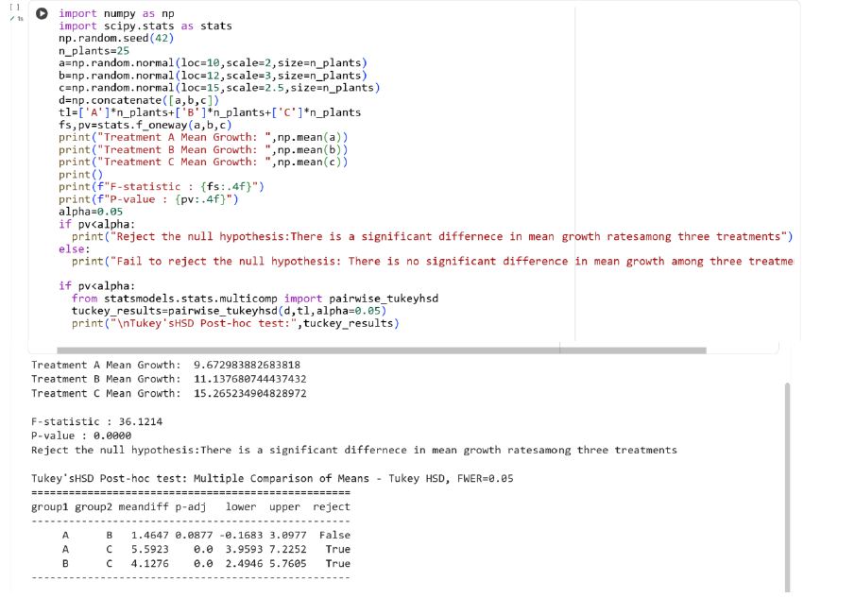

Result:
Thus the python program for hypothetical using ANOVA test is executed and output verified successfully

